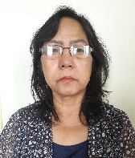
Photo
3.5x4.5cm

1 | Name  Address  Contact info | HMINGTHANTLUANGI  Tlangnuam, Aizawl  9089530080  Email- Hmingthantluangi@gmail.com
2 | Date of Birth  Date of retirement | 01.03.1961  28.02.2021
3 | Academic Qualification | B.A.
4 | Details of Family | Spouse- -  Son-3  Daughter-2
5 | Mode, Date & Year of entry to MFAS | Promotion  25.04.2017
6 | Present post held | F.A.O, PWD (Buildings)  (Addl. charge of F.A.O, PWD (Highways) wef. 08.03.2019)
7 | Previous post held | A&AO

